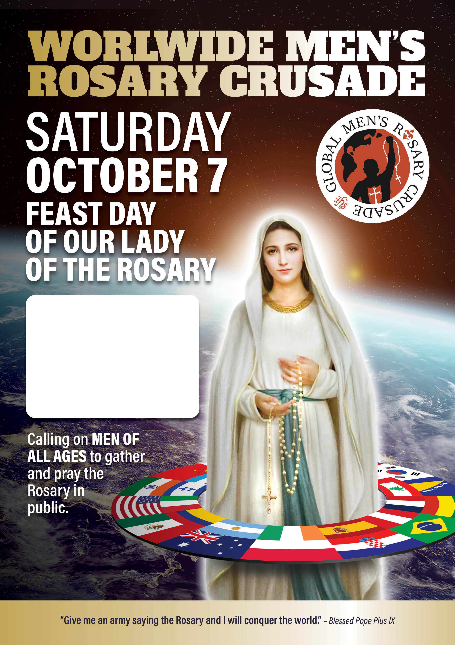
1pm
St Mary’s Cathedral
Forecourt

Confessions available from
11am and Mass at
12pm in St Mary’s Cathedral

